CHILTERN CHEETAHS
MONTHLY NEWSLETTER
 | FEBRUARY- 2020
What’s with all the pizza?
Wondering why we seem to be eating a lot of pizza? Read more on page 2
ATHLETE OF THE MONTH
Ella L!
Ella stepped up to Momentum following an athlete injury, worked extremely hard and hit at comp!
 | legacy just believe competition
 | On Saturday and Sunday February 15th and 16th, we headed into London for our first competition of the season- Legacy Just Believe!  Legacy is an American competition provider, created and run by twins Aly and Andrea Kulberg (who are based in Texas, US), who run these competitions in both England and America. |  |  |  |  |  |  |  | We took just four of our cheer teams and two of our dance teams to this competition, and certainly hit the ground running with some fantastic scores and results (outlined in more detail on page 2).  We are particularly proud of Hurricane for winning GRAND CHAMPS (highest score)out of levels 1 and 2 across all youth and junior teams that weekend! Well done! |  |  |  | athlete OF THE MONTH  Chloe B!  Chloe has improved so much as an all round athlete and we are so proud of her ongoing hard work and determination!
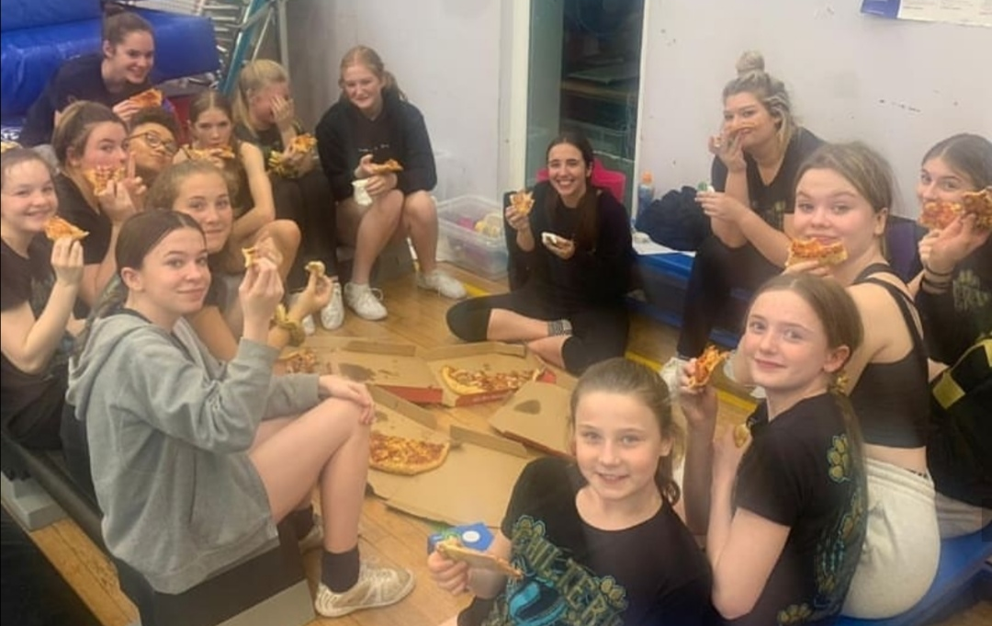
February- 2020

What’s with all the pizza?
You may have seen on our social media that teams are enjoying ‘pizza’ parties at the gym. The reason for this is that we wanted to reward teams for 100% team attendance over a certain period of time.
Cheerleading is a team sport, and committing to training once or twice (or more!) a week, every week, requires sacrifice from our athletes (and families), so when a team has fully committed together, we like to celebrate!
Legacy Competition Results  Hurricane (Junior 2): 1st place, hit zero and GRAND CHAMPS  Revolution (Junior dance): 1st place  Momentum (International Junior 3): 2nd place and hit zero  Lightning (Youth 2): 2nd place and hit zero  Illusion (Youth dance): 2nd place  Velocity (Senior 2): 4th place |  |  |  |  |  |  |  |  |  |  | REMINDER:  Don’t forget to buy your spectator tickets for competitions this year via the website (‘orders’> ‘tickets’)  The deadline for these is APRIL 1ST!
OFFERS/UPCOMING EVENTS NEXT MONTH |  |  |  |  |  |  |  |  |  | 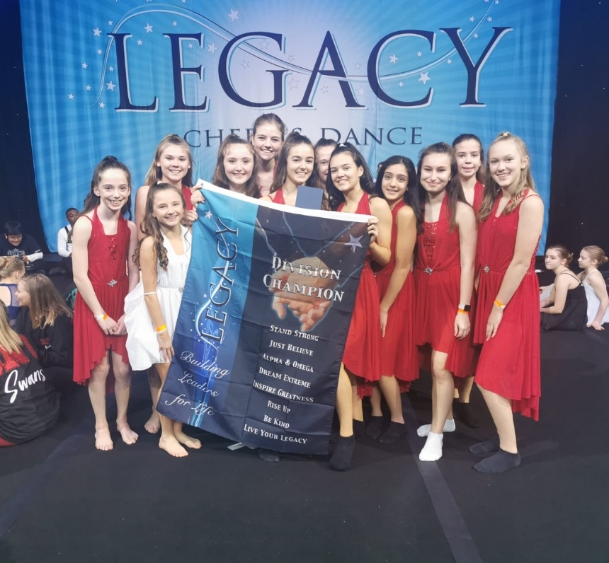
01  Next competition: Legacy Birmingham: March 21st & 22nd |  |  |  |  | 02  Private tumble sessions: see website for availability
03  New merchandise on the website- Chiltern Cheetahs lunch box! |  |  |  |  | 04  Know someone who should try cheer? We have trials available

