CHILTERN CHEETAHS
MONTHLY NEWSLETTER
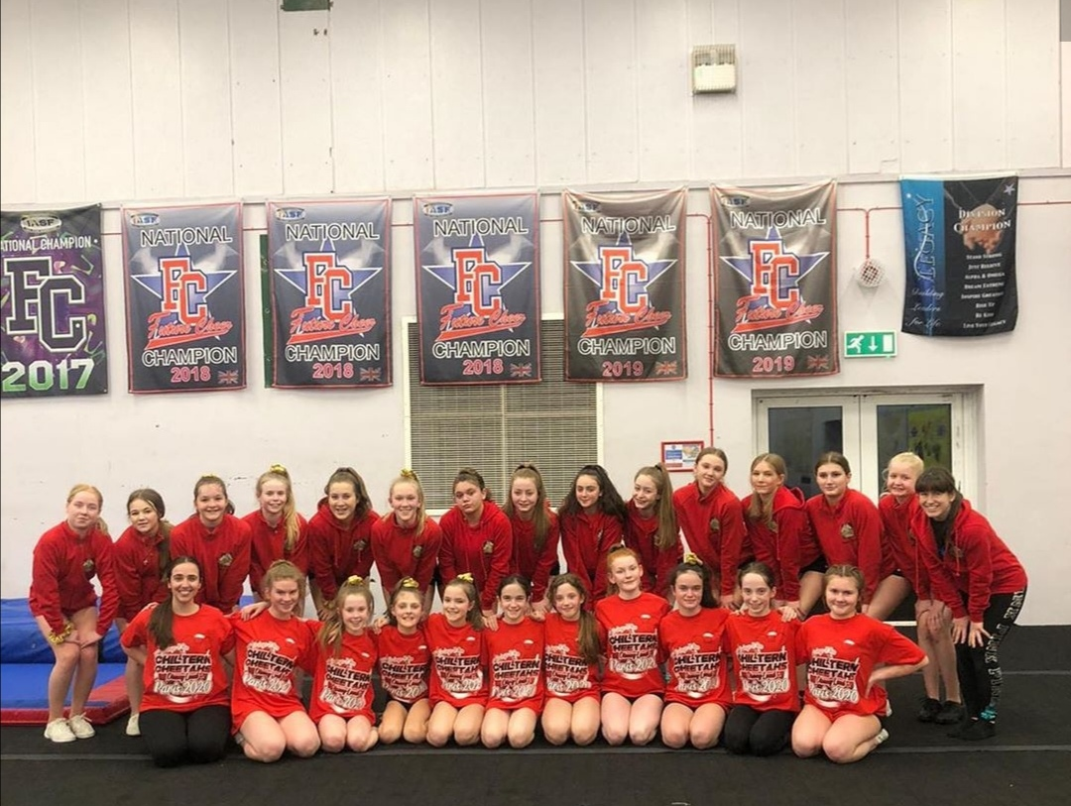 | MARCH/APRIL- 2020  INSERT PHOTO HERE
NEWS on page 2
We discuss how we are managing to stay fit and motivated from home.
ATHLETE OF THE MONTH
Rebecca from Lightning, for her continued hard work outside of the gym.
 | TOP NEWS: VIRTUAL TRAINING
 | It is crazy for me to think that when I was writing the last newsletter, Corona Virus was just this bug that we’d all heard about from China. If someone had told me back then that school would shut, cheer would shut, café’s/ bars/ restaurants would close and our way of life would completely change- I don’t think any of us would have believed it. |  |  |  | Yet here we are!  As coaches, we are continually working hard to plan and deliver virtual cheer sessions. While we are missing the key element of cheer (stunting), there is still plenty we are doing to keep up strength and stamina. And getting to see everyone’s faces is cheering us all up! | FLYER OF THE MONTH  Amelia from Cubs, for working all of her skills every day at home while the gym is closed!

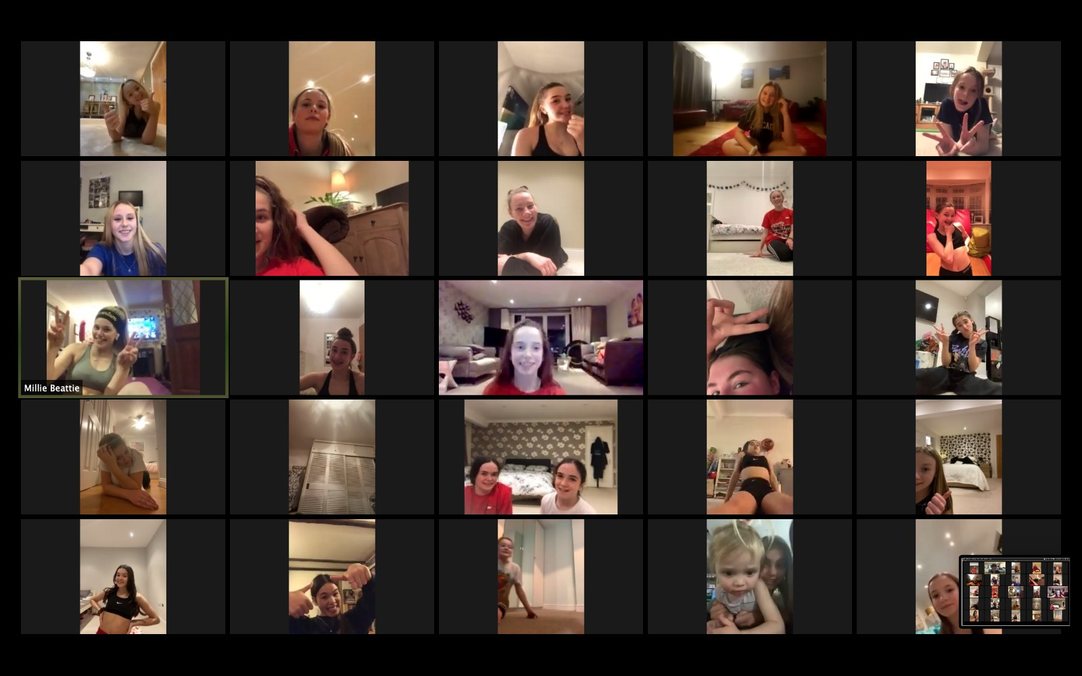
march/APRIL- 2020
INSERT PHOTO HERE
How to stay motivated:
During these uncertain times, life might be tough for everyone. But there are definitely some things you can do to stay motivated:
-Set and stick to a routine
-Exercises every day
-Get out of the house for fresh air
-Cook/ bake new recipes
-Host family games/ show night
-Try not to check the news every 5 minutes; most of what is happening in the world is outside of our control.
-Focus on the positives!

Let’s stay positive:
“Tough times don’t last- tough people do”
 |  |  |  |  | INSERT PHOTO/ PHOTOS HERE
How are we supporting our athletes? |  |  |  |  | 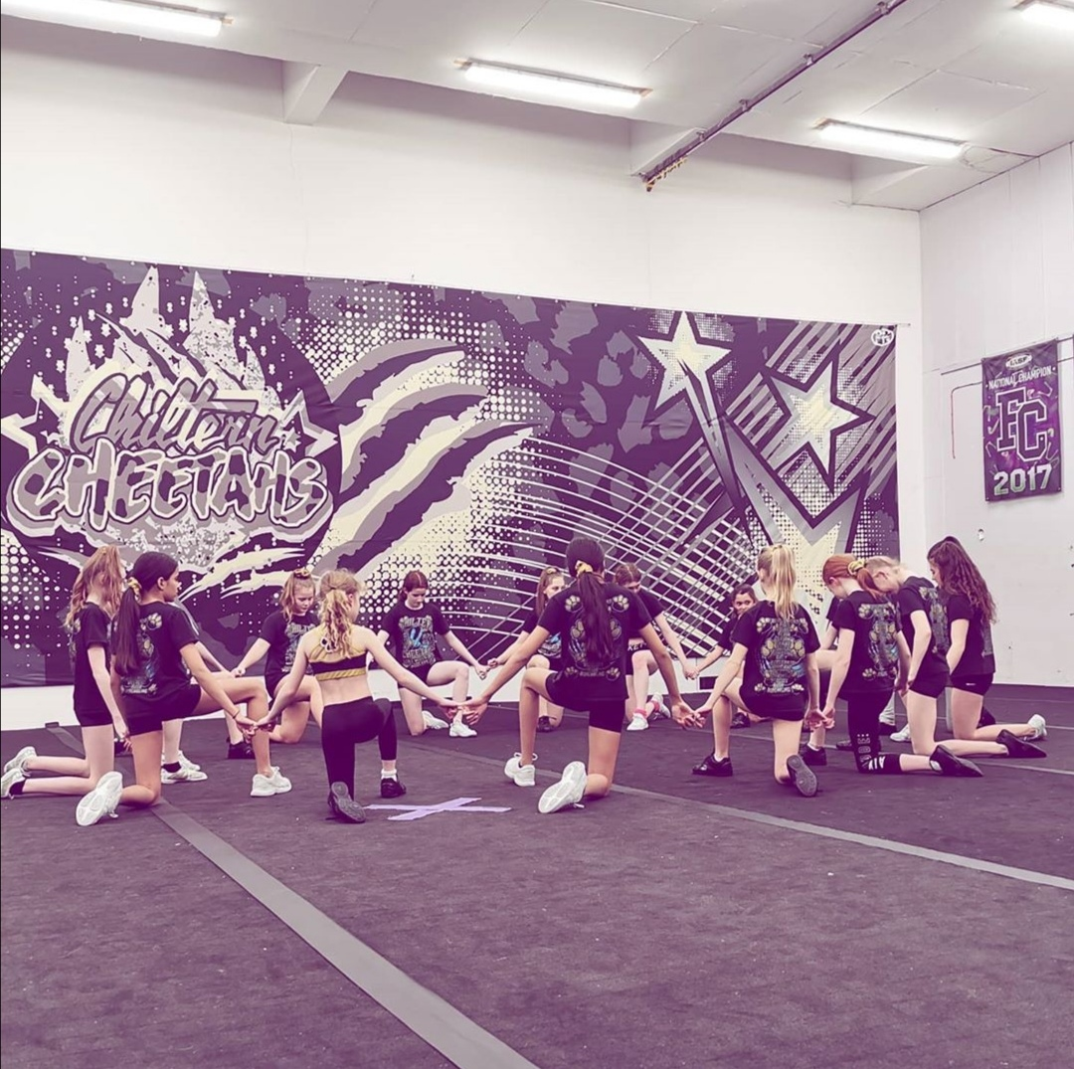
01  Virtual coaching at usual training times |  |  | 02  5 extra challenges set online per week
03  LIVE follow along workouts every day |  |  | 04  Lots of resources to download  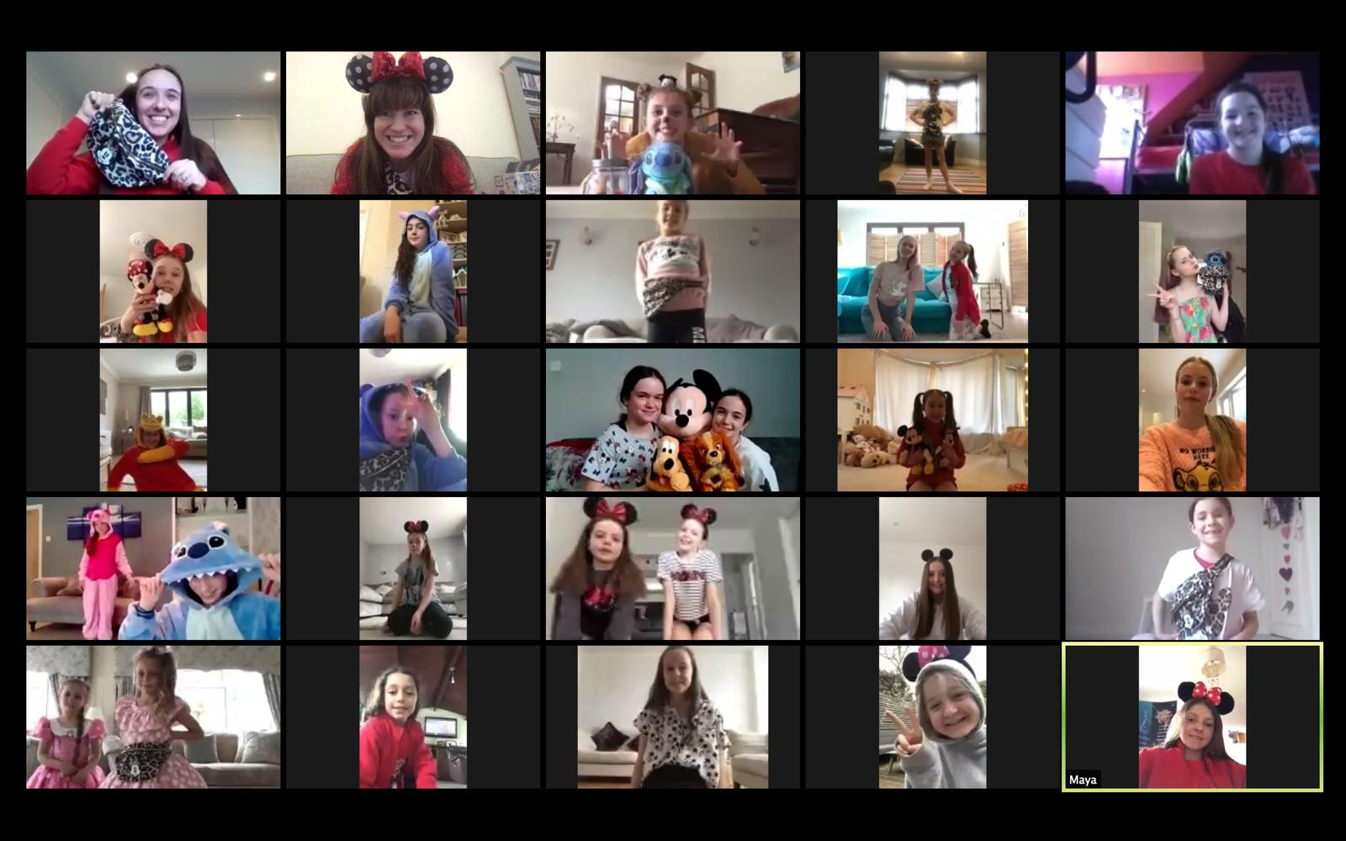
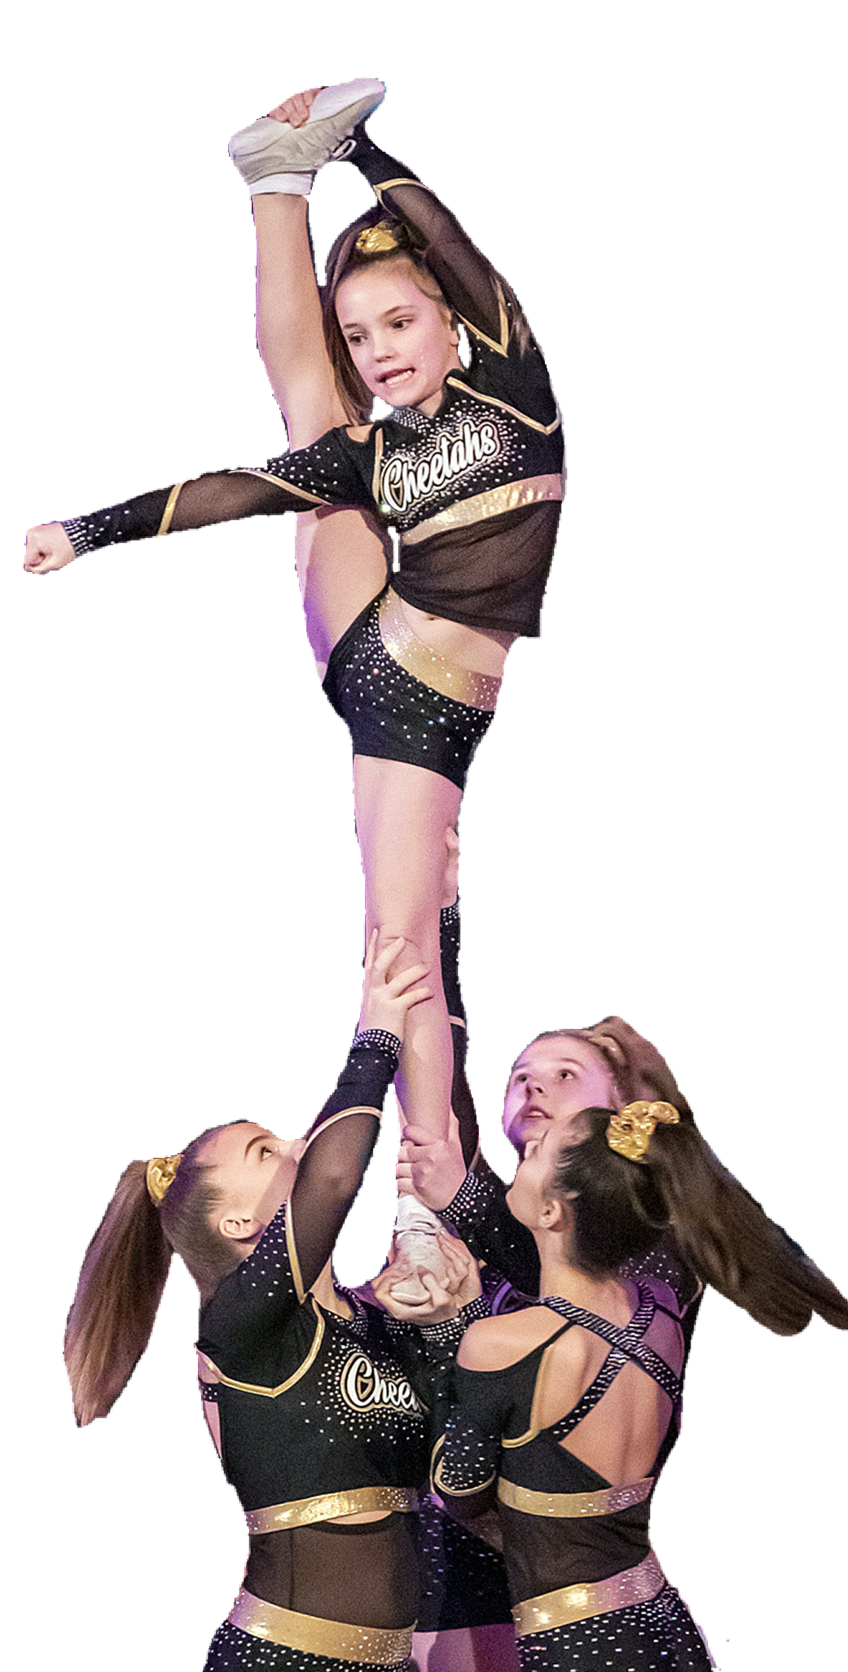
“Can I just say a big THANK YOU for this. Just what the girls need to keep some normlity, keep active, keep hapy and keep their mental health positive. Can’t thank you enough”
“I had so much fun today, I loved EVERYTHING we did! You are the best coaches and teammates I could ask for!!! Thank you so much Kerri, Jess and everybody else for making me super happy”
“I just wanted to let you know that (athlete) really enjoyed the virtual class. Such a great idea!”
“Thank you jess and all the other girls that are part of your team… doing an amazing job to keep girls focused and being an amazing CC family, love this!”
“I just wanted to say thank you for your perseverance through this tough time. I know it’s not been easy but the things we are currently doing, such as zoom, are really motivating. It gives us time to focus on a sport we love when we have nothing else to do. Thank you the most”
“Thank you for setting up the Disney party. So great to see all the girls chatting to each other. I could have watched them all night, they are hysterical!”
“Thank you for doing the Disney party today- such a lovely idea. (Athlete) loved it. I have to say that all the cheer still going on virtually has really helped her. Thank you”
“Just to let you know (athlete) is loving the zoom sessions, so tired after but buzzing. They really are great for keeping them fit and motivated.”
What are our athletes and families saying about continuing to train via zoom while the gym is closed?
Disney Party
On Saturday March 28th, we would have been competing at Future Cheer Paris with Hurricane, Lightning, Storm and our two dance teams; Revolution and Illusion (as well as a number of dance solos).
However, instead of feeling sad about the fact that we weren’t there, we held a Disney party via Zoom instead! We all dressed up in our various merchandise, with our various ‘extras’ (Disney ears, minnie mouse bow, bumbags etc.), and celebrated together. It was brilliant!

What’s coming up in April?
We are extremely excited to announce that we have a series of online zoom sessions being hosted by worldwide respected athletes/ coaches…
The first one is open to our junior and senior athletes, and is being led by Robert Scianna! Robert is an athlete, coach, choreographer and model. He is a NCA Champion, Majors champion and a 2 time World Champion. Robert has cheered for numerous programs around the United States including FAME allstars, California Allstars, GymTyme Allstars and Fire & Ice Allstars.
Who are the other sessions being hosted by? Wait and see….
We also have extra sessions being offered to our tiny and mini athletes, such as Cheer ‘Storytime sessions’ and fancy dress fun via zoom!

Is your child struggling with their mental health?
We fully recognise that a routine and structure is important for everyone, as well as the fact that being at cheer is a positive in our athletes’ lives. Without it, they may be feeling a bit out of sorts.
We are pleased to be able to offer 1-on-1 support sessions (via zoom) free of charge to any of our athletes that feel they would benefit from this- even if they just need a chat with someone outside their house about how they’re feeling. These would be with either Jess or Alex (our mental health first aiders).
Please email info@chilterncheetahs.co.uk to book.

Just because the gym is closed, doesn’t mean the parties have to stop!
We are still awarding teams for full team attendance, and plan to host virtual ‘pizza parties’ with our teams once they have reached their attendance goals. We love celebrating together, regardless of whether it’s in person or online!
Another extra that we are planning for our athletes is team quiz nights! We plan to host a variety of quiz nights appropriate to each age group, with prizes for winners…..!
We loved dressing up at training, and that will be carrying on via zoom too- keep your eye out for details of the next themed fancy dress sessions!
WE WANT YOU to let us know any other extras that you would like to see! Drop us a message on Instagram, Facbeook or email info@chilterncheetahs.co.uk
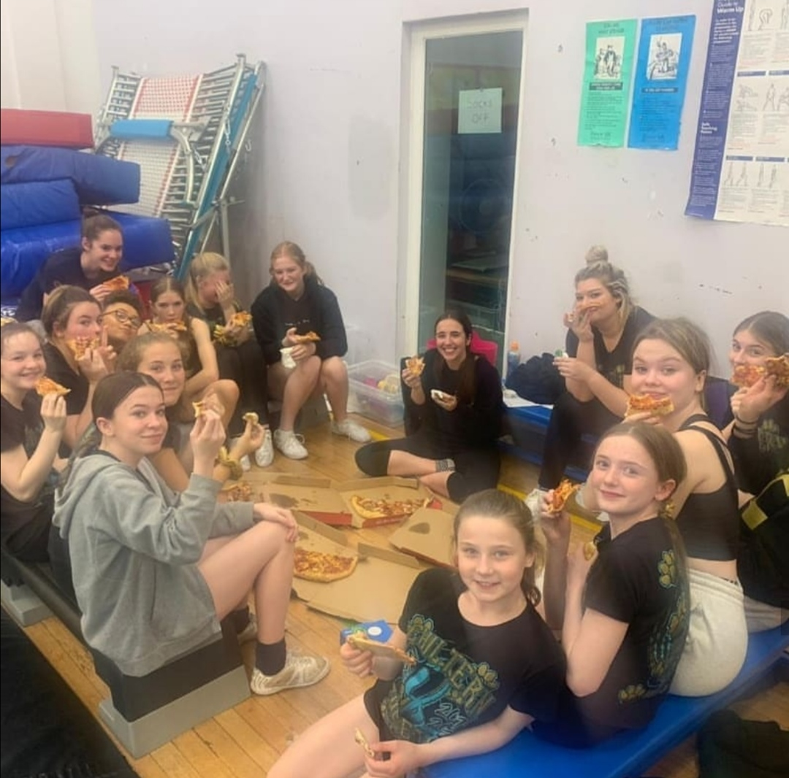

Timetable for April
We are still working full time to make sure that our athletes are focused and motivated!
We are still working full time to make sure that our athletes are focused and motivated!
MONDAY –
5.30-7 pm – Youth and Junior dancers
5.30-6.30pm – All Development classes
7-8.30pm – Stealth and Swift

TUESDAY -
5.30-7pm – Lightning and Storm
7-8.30pm – Momentum and L3 Stunt group

WEDNESDAY –
3.30-4.30pm – The Misbourne School
6.30-8pm – Hurricane
8-9.30pm – Rush

THURSDAYS –
5.30-7pm – Momentum and Velocity
7-8.30pm – Adrenaline

FRIDAYS –
5.30-6.30pm – Accelerate

SATURDAYS –
9-10am – Tiny’s Dance
10-11am –Cubs and Paws
11-12.30pm – Swift
12.30-2pm - Flash
2-3.30pm - Lightning and Hurricane

SUNDAYS –
3.30-5pm - Accelerate and Velocity
5 - 6.30pm - Strike and Bolt
6.30-8pm - Adrenaline, Rush

